附件2：
 |  | China
 |  | Deloitte.com China Privacy

 | 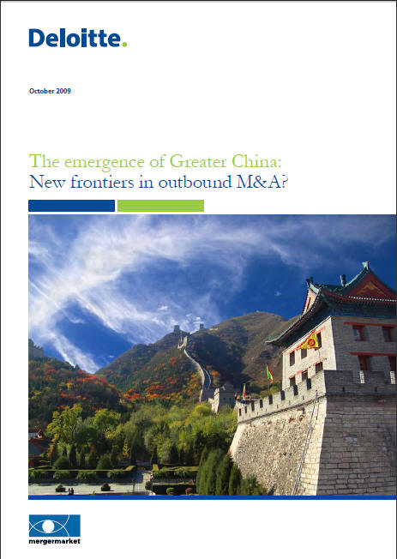 |  | Global Chinese Services Group 全球中国服务小组
Forging ahead through challenging times
长风破浪会有时 直挂云帆济沧海

Tax Management of Outbound Investment Seminar
“中国企业走出去”税务管理研讨会

德勤诚挚邀请您于11月27日参加“中国企业走出去”税务管理研讨会。

研讨会将邀请已经进行境外投资或计划进行境外投资的大型国有企业的财务高层管理人员，诸如总会计师，财务部总经理，财务处长等参加，探讨中国企业海外并购、工程承包等跨境投资活动所关注的国内和国际税务事项、跨境交易的税务筹划机会和全球税务风险管理等方面的内容。

国家税务总局国际税务司廖体忠副司长将作为研讨会的演讲嘉宾，就中国企业对外投资的税法最新进展和税务机关实践操作发表演讲。

我们谨代表德勤同仁期待您的光临。

时间： 2009年11月27日下午2:00 至5:00
地点： 王府半岛酒店

Deloitte sincerely invites you to attend the Tax Management of Outbound Investment Seminar on November 27th.

This seminar invites senior finance executives of state-owned enterprises which have already made or plan to make investment overseas. Topics covered include domestic and international tax issues related to Chinese enterprises' cross-border investment activities (e.g., overseas M&A and contracting of engineering projects), tax planning opportunities for cross-border transactions, global tax risk management, etc.

Mr. Liao Tizhong, Vice Director of International Taxation, State Administration of Tax, will make a speech on the updates of China tax legislation and administrative practice on outbound investment by Chinese enterprises.

On behalf of our Deloitte professionals, we look forward to your attendance.

Time: 2:00-5:00 pm, November 27th, 2009
Venue:.
30/F Bund Center
222 Yan An Road East
Shanghai 200002, China

©2008 Deloitte Touche Tohmatsu in Hong Kong SAR, Deloitte Touche Tohmatsu in Macau SAR, and Deloitte Touche Tohmatsu Certified Public Accountants Ltd. in the Chinese Mainland. All rights reserved.

Deloitte refers to one or more of Deloitte Touche Tohmatsu, a Swiss Verein, and its network of member firms, each of which is a legally separate and independent entity. Please see www.deloitte.com/cn/en/about for a detailed description of the legal structure of Deloitte Touche Tohmatsu and its Member Firms.
中国上海市延安东路222号
外滩中心30楼
邮政编码：200002
©2008德勤•关黄陈方会计师行（香港特别行政区）、德勤•关黄陈方会计师行（澳门特别行政区）、德勤华永会计师事务所有限公司（中国大陆）版权所有 保留一切权利
Deloitte (“德勤”) 泛指根据瑞士法律组成的社团性质的组织Deloitte Touche Tohmatsu (“德勤全球”)，以及其一家或多家成员所/公司。每一个成员所/公司均为具有独立法律地位的法律实体。请参阅 www.deloitte.com/cn/about 中有关德勤全球及其成员所法律结构的详细描述。

