附件一：
邀请函
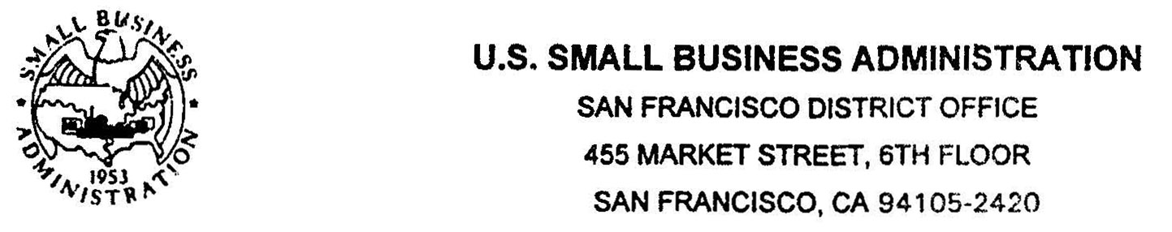

August 25, 2010

To China Association of Chief Financial Officers
Beijing, China

It is with great pleasure to learn that the China Association of Chief Financial Officers is planning to sponsor the fourth Sino-United States SME Investment Forum to be held on November of 2010 respectively in New York City and San Francisco. The conference of November 10-11 in NYC will be organized by SBA New York District Office, and the conference of November 19 in San Francisco will be organized by our office and San Francisco Mayor's Office of International Trade and Commerce.

We understand the conference will focus on investment, import & export, technology transfer, franchise development between the United States and China, and issues like brand cultivation of Small and Medium Enterprises, and the impact of financial crisis on Small and Medium Enterprises, is perfectly in compliance with our mission.

San Francisco would be a very good location for the event. Our local business persons, franchisers, entrepreneurs and government officials would be very interested in attending and participating in the conference. Here I would like to inform you that my office would be very willing to work closely with your organization, San Francisco Mayor's Office of International Trade and Commerce and American International Exchange Group to make the fourth Sino-United States SME Investment Forum a great success.

I look forward to further discussing the proposed event with you, and please keep me informed of any progress with this event on China side.

