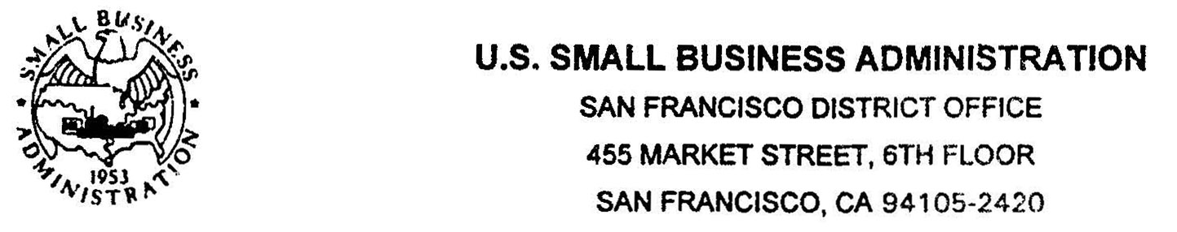
附件一：

August 23, 2011

To China Association of Chief Financial Officers
Beijing, China

It is with great pleasure to learn that the China Association of Chief Financial Officers is planning to sponsor the fifth Sino-United States SME Investment Forum to be held on October 19th to 21st of 2011 in San Francisco, California.

We understand the conference will focus on investment, import & export, technology transfer, franchise development between the United States and China, and issues like brand cultivation of Small and Medium Enterprises, and the impact of financial crisis on Small and Medium Enterprises, which are perfectly in compliance with our mission.

San Francisco would be a very good location for the event. Our local business persons, franchisers, entrepreneurs and government officials would be very interested in attending and participating in the conference. Here I would like to inform you that my office would be very willing to work closely with your organization, San Francisco Mayor's Office of International Trade and Commerce and American International Exchange Group to make the fourth Sino-United States SME Investment Forum a great success.

I look forward to further discussing the proposed event with you, and please keep me informed of any progress with this event on China side.

Sincerely,
